**Practical No. 10**

**Implementation of K NN Clustering on Jupyter Notebook using Python.**

import numpy as np  
import pandas as pd  
from matplotlib import pyplot as plt  
from sklearn.datasets import load_breast_cancer  
from sklearn.metrics import confusion_matrix  
from sklearn.neighbors import KNeighborsClassifier  
from sklearn.model_selection import train_test_split  
import seaborn as sns  
sns.set()

breast_cancer = load_breast_cancer()  
X = pd.DataFrame(breast_cancer.data, columns=breast_cancer.feature_names)  
X = X[['mean area', 'mean compactness']]  
y = pd.Categorical.from_codes(breast_cancer.target, breast_cancer.target_names)  
y = pd.get_dummies(y, drop_first=True)

X_train, X_test, y_train, y_test = train_test_split(X, y, random_state=1)

knn = KNeighborsClassifier(n_neighbors=5, metric='euclidean')  
knn.fit(X_train, y_train)

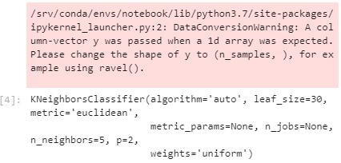

y_pred = knn.predict(X_test)

sns.scatterplot(  
x='mean area',  
y='mean compactness',  
hue='benign',  
data=X_test.join(y_test, how='outer')  
)

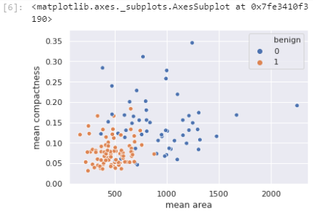

plt.scatter(  
X_test['mean area'],  
X_test['mean compactness'],  
c=y_pred,  
cmap='coolwarm',  
alpha=0.7  
)

